Supplementary Materials

SM.1. Overview over sample demographics by country
Table S1. Overview of Demographic Information for Final Study Sample by Collection Site
Country | Men | Women | Age | SES
Canada | 196 | 204 | 48.71 (15.90) | 6.11 (1.72)
Greek Cypriot Community | 138 | 122 | 46.60 (15.38) | 5.59 (1.61)
Turkish Cypriot Community | 206 | 184 | 43.84 (13.45) | 5.77 (2.04)
Egypt | 190 | 189 | 32.38 (9.48) | 5.35 (1.97)
Greece | 196 | 194 | 43.76 (13.46) | 5.47 (1.69)
Italy | 199 | 193 | 43.00 (16.86) | 5.86 (1.59)
Japan | 194 | 195 | 49.70 (13.6) | 4.86 (1.93)
Korea | 190 | 197 | 44.36 (13.23) | 4.84 (1.99)
Lebanon | 192 | 182 | 31.62 (9.97) | 5.16 (2.01)
Spain | 197 | 199 | 44.19 (14.33) | 5.94 (1.62)
Tunisia | 187 | 183 | 34.36 (10.36) | 5.34 (1.82)
Turkey | 194 | 197 | 38.35 (12.99) | 6.23 (1.85)
UK | 192 | 197 | 50.42 (16.55) | 5.31 (1.90)
United States | 195 | 195 | 47.17 (16.28) | 6.47 (2.30)
Total | 2666 | 2631 | 42.75 (15.12) | 5.6 (1.94)
Note. Values for age and SES represent means with standard deviations in brackets.

SM.2. Graphical overview over country descriptives for study variables
Figure S1
Average ratings for apology beliefs of morality and effectiveness by country
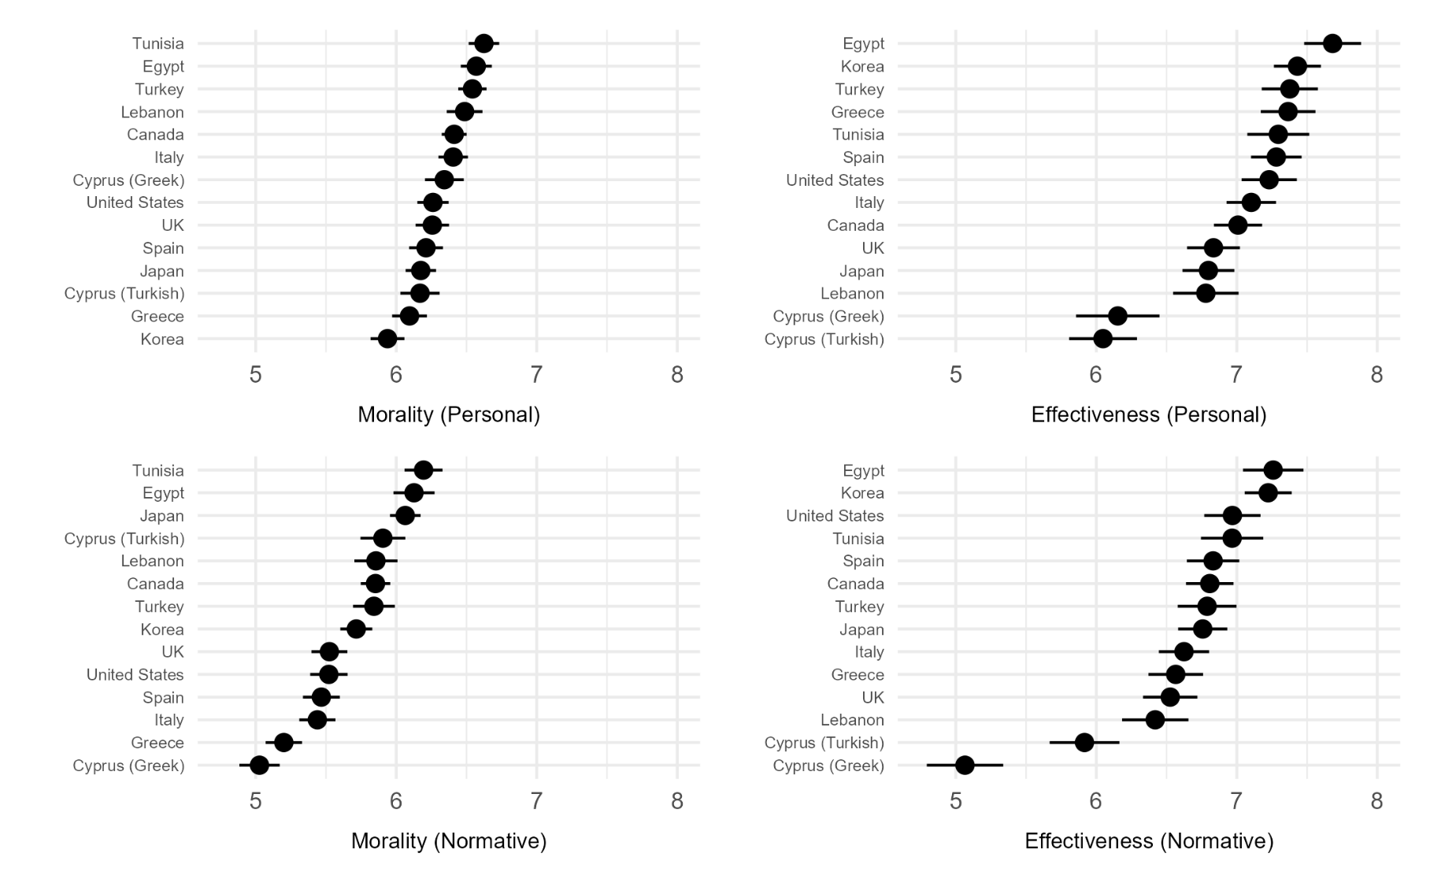
Figure S2
Average ratings for apology beliefs of admissions of responsibility by country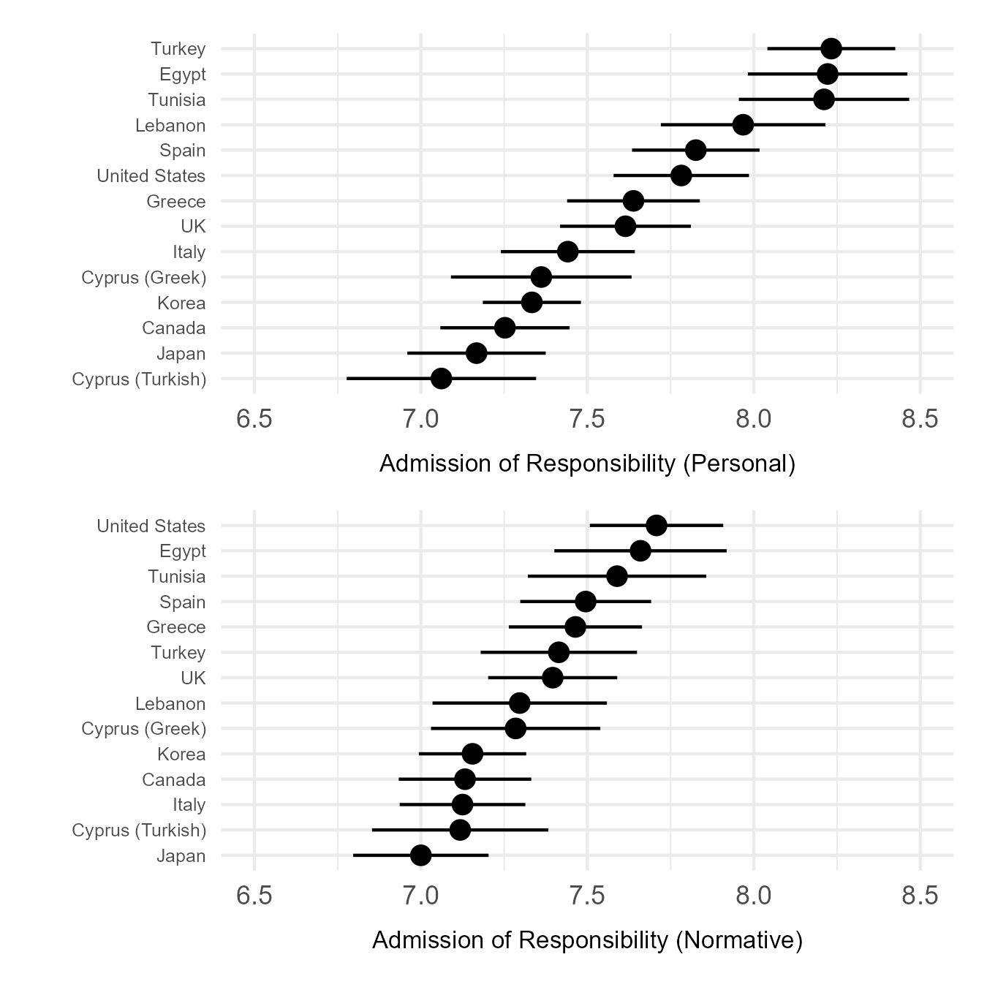

SM.3. Measurement Models of Multi-Item Scales
This section outlines the measurement models used at both the individual and cultural levels for the multi-item scales central to our primary analyses—namely, willingness to apologize, personal perceptions of apology effectiveness, and perceived normative perceptions of apology effectiveness. Equivalent models for the honor value scales are presented elsewhere (Vignoles et al., 2024).
For each scale, we ran a separate but parallel series of multi-level measurement models, accounting for the hierarchical nature of the data (with participants nested within cultural groups defined by the intersection of country and gender) and adjusting for differences in acquiescent responding.
First, we started with an exploratory factor analysis (EFA) to identify the underlying structure of the items at the individual level. To account for clustering within 28 cultural groups, we used the TYPE=COMPLEX option in Mplus.
Second, we proceeded with a confirmatory factor analysis (CFA) to test the structure emerging from the EFA, again employing TYPE=COMPLEX to address data clustering. To capture acquiescence bias, we included a method factor, defined as a latent factor with all item loadings fixed at 1 and no correlation with the substantive factors (following Welkenhuysen-Gybels et al., 2003). If model fit was suboptimal, we examined suggested modification indices and item loadings—together with theoretical considerations—to refine the item structure as needed.
Third, we assessed metric invariance of the within-group CFA structure across different cultural regions and gender groups using multigroup invariance testing. The 28 cultural groups were organized into five regional clusters, based on prior research examining socio-demographic, linguistic, religious, and historical factors (Mensah & Chen, 2012): Anglo-West (UK, US, Canada), Latin Europe (Spain, Italy), Southeastern Europe (Greece, Greek Cypriot Community), MENA (Türkiye, Lebanon, Egypt, Turkish Cypriot Community, Tunisia), and East Asia (Japan, South Korea). Invariance was tested using two-level multigroup CFA models, with group-mean-centered items and no structure specified at the between-groups level. Following standard practice, we compared constrained models (equal loadings across regions or gender groups) to unconstrained models (freely estimated loadings). A difference in CFI of ≤ .01 between these models was used to support metric invariance (Cheung & Rensvold, 2002). Items were flagged as potentially non-invariant and considered for exclusion if (a) the constrained model showed a modification index above 10 suggesting significant cross-group differences in loadings, and (b) one or more item loadings in the unconstrained model were non-significant.
All analyses were carried out using Mplus Version 8.5 (Muthén & Muthén, 1998). Model fit was assessed using the Comparative Fit Index (CFI), Tucker-Lewis Index (TLI), Root Mean Square Error of Approximation (RMSEA), and Standardized Root Mean Squared Residual (SRMR). We adopted commonly used benchmarks for evaluating fit—CFI and TLI values above .95 (or .90), RMSEA below .06 (or .08), and SRMR below .08 (or .10)—as suggested by Hu and Bentler (1999) and Kline (2023). These benchmarks should be interpreted as general guidelines rather than strict cut-offs, especially given the complexity of our cross-cultural, multi-factor models (Marsh et al., 2004).

SM.3.1. Willingness to Apologize
We first conducted an exploratory factor analysis to identify the underlying structure for these items at the individual level. Please note that the original items were adjusted from Hornsey and colleagues (2017) to measure reluctance to apologize; we therefore conducted the measurement models in this direction and subsequently reversed the item direction in the main analyses of the current paper to assess willingness to apologize. Items were uncentered and clustered by the 28 samples made up by the combination of gender (male vs female) and country. A one-factor solution appeared to be the most theoretically meaningful and parsimonious solution. A two-factor or three-factor solution did not converge. Fit of the final one-factor solution was not considered adequate (χ2[2] = 230.593, CFI = .351, TLI = .000, SRMR = .111, RMSEA = .145); however given that a following CFA including a method factor improved the fit of the one-factor solution we interpreted this as being due to the missing control for response tendencies in the EFA, not due to the conceptual structure of the model.
Table S2
Exploratory Factor Analysis Loadings of Reluctance to Apologize Items
Item | Reluctance to  Apologize
I am unlikely to apologize if I have done something wrong. | .287
I rarely apologise to other people. | .243
In general, I apologise after having done something wrong. | -.749
After I have done something wrong, I usually apologize. | -.758
Note. Shown are the standardized loadings for the final one-factor solution of the exploratory factor analysis conducted with the reluctance to apologize items.

In the second step, we conducted a confirmatory factor analysis with the one-factor structure as well as a method factor to assess acquiescence in responding (see Table S3 for primary loadings on substantive factors). Fit of the model was excellent (χ2[1] = 1.266, CFI = .999, TLI = .995, SRMR = .002, RMSEA = .007), and loadings for all items were significant. No modification indices emerged.
Table S3
Confirmatory Factor Analysis Loadings of Reluctance to Apologize Items
Item | Reluctance to  Apologize
I am unlikely to apologize if I have done something wrong. | .607
I rarely apologise to other people. | .536
In general, I apologise after having done something wrong. | -.605
After I have done something wrong, I usually apologize. | -.607
Note. Shown are the standardized loadings for the final one-factor solution of the confirmatory factor analysis conducted with the reluctance to apologize items.
In the third step, we conducted multigroup invariance testing with the established one-factor structure. We tested invariance both across cultural regions, and across genders (female and male). An unconstrained model fit better than a constrained model across cultural regions (Constrained: χ2[37] = 80.154, CFI = .975, TLI = .980, SRMR = .015, RMSEA = .034; Unconstrained: χ2[24] = 21.366, CFI = 1.000, TLI = 1.000, SRMR = .003, RMSEA = .000; ΔCFI = .025), but not across gender groups (Constrained: χ2[13] = 2.208, CFI = 1.000, TLI = 1.000, SRMR = .002, RMSEA = .000; Unconstrained: χ2[10] = 3.096, CFI = 1.000, TLI = 1.000, SRMR = .001, RMSEA = .000; ΔCFI = .000). We thus assumed invariance of our items across genders, but we followed up our invariance analysis on an item-by-item basis across regions, in which all of the 4 items met our criteria for invariance across regions (no combination of modification index in the constrained model and non-significant loading in the unconstrained model). We there did not exclude any items in this step.

SM.3.2. Personal Beliefs of Apology Effectiveness
We first conducted an exploratory factor analysis to identify the underlying structure for these items at the individual level. Items were uncentered and clustered by the 28 samples made up by the combination of gender (male vs female) and country. A one-factor solution appeared to be the most theoretically meaningful and parsimonious solution with very good fit (χ2[5] = 54.377, CFI = .979, TLI = .958, SRMR = .016, RMSEA = .043). While a two-factor provided somewhat better model fit (χ2[5] = 0.926, CFI = 1.00, TLI = 1.00, SRMR = .003, RMSEA = .000), it also suggested a single-item factor that was additionally strongly correlated with the second factor (r = .841); a three-factor solution did not converge. Considering the already good fit of the one factor structure, we therefore decided to continue with a one factor solution.
Table S4
Exploratory Factor Analysis Loadings of Personal Apology Effectiveness Beliefs Items
Item | Personal Apology Effectiveness Beliefs
…restoring a damaged relationship? | .816
…promoting forgiveness? | .796
…repairing the damaged trust between individuals after wrongdoing? | .845
…repairing the damaged reputation of the wrongdoer? | .802
…restoring one’s personal sense of integrity? | .779
Note. Shown are the standardized loadings for the final one-factor solution of the exploratory factor analysis conducted with the personal apology effectiveness beliefs items.
In the second step, we conducted a confirmatory factor analysis with the one-factor structure as well as a method factor to assess acquiescence in responding (see Table S5 for primary loadings on substantive factors). Fit of the model was good (χ2[30] = 550.032, CFI = .912, TLI = .895, SRMR = .067, RMSEA = .056), and loadings for all items were significant. No modification indices emerged.
Table S5
Confirmatory Factor Analysis Loadings of Personal Apology Effectiveness Beliefs Items
Item | Personal Apology Effectiveness
…restoring a damaged relationship? | .785
…promoting forgiveness? | .761
…repairing the damaged trust between individuals after wrongdoing? | .816
…repairing the damaged reputation of the wrongdoer? | .774
…restoring one’s personal sense of integrity? | .747
Note. Shown are the standardized loadings for the final one-factor solution of the confirmatory factor analysis conducted with the personal apology effectiveness beliefs items.
In the third step, we conducted multigroup invariance testing with the established one-factor structure. We tested invariance both across cultural regions, and across genders (female and male). An unconstrained model fit the data as well as an unconstrained model across regions (Constrained: χ2[206] = 1362.743, CFI = .920, TLI = .930, SRMR = .028, RMSEA = .072; Unconstrained: χ2[186] = 1249.824, CFI = .926, TLI = .928, SRMR = .027, RMSEA = .072; ΔCFI = .006), whereas an unconstrained model did not converge for gender groups (Constrained: χ2[80] = 839.321, CFI = .865, TLI = .879, SRMR = .029, RMSEA = .059). We thus assumed invariance of our items across regions and did not exclude any items in this step.

SM.3.3. Normative Beliefs of Apology Effectiveness
We first conducted an exploratory factor analysis to identify the underlying structure for these items at the individual level. Items were uncentered and clustered by the 28 samples made up by the combination of gender (male vs female) and country. A one-factor solution appeared to be the most theoretically meaningful and parsimonious solution with very good fit (χ2[5] = 41.804, CFI = .984, TLI = .968, SRMR = .013, RMSEA = .037). While a two-factor provided somewhat better model fit (χ2[5] = 2.201, CFI = .999, TLI = .995, SRMR = .003, RMSEA = .015), it also suggested high collinearity between the two factors (r = .886) and a somewhat mixed loading structure; a three-factor solution did not converge. Considering the already good fit of the one factor structure, we therefore decided to continue with a one factor solution.
Table S6
Exploratory Factor Analysis Loadings of Normative Apology Effectiveness Beliefs Items
Item | Personal Apology Effectiveness Beliefs
…restoring a damaged relationship? | .834
…promoting forgiveness? | .786
…repairing the damaged trust between individuals after wrongdoing? | .851
…repairing the damaged reputation of the wrongdoer? | .807
…restoring one’s personal sense of integrity? | .789
Note. Shown are the standardized loadings for the final one-factor solution of the exploratory factor analysis conducted with the normative apology effectiveness beliefs items.
In the second step, we conducted a confirmatory factor analysis with the one-factor structure as well as a method factor to assess acquiescence in responding (see Table S7 for primary loadings on substantive factors). Fit of the model was good (χ2[30] = 547.906, CFI = .915, TLI = .898, SRMR = .060, RMSEA = .056), and loadings for all items were significant. No modification indices emerged.
Table S7
Confirmatory Factor Analysis Loadings of Normative Apology Effectiveness Beliefs Items
Item | Personal Apology Effectiveness
…restoring a damaged relationship? | .801
…promoting forgiveness? | .752
…repairing the damaged trust between individuals after wrongdoing? | .819
…repairing the damaged reputation of the wrongdoer? | .773
…restoring one’s personal sense of integrity? | .756
Note. Shown are the standardized loadings for the final one-factor solution of the confirmatory factor analysis conducted with the normative apology effectiveness beliefs items.
In the third step, we conducted multigroup invariance testing with the established one-factor structure. We tested invariance both across cultural regions, and across genders (female and male). An unconstrained model fit the data as well as an unconstrained model across regions (Constrained: χ2[206] = 1585.273, CFI = .920, TLI = .930, SRMR = .028, RMSEA = .078; Unconstrained: χ2[186] = 1473.132, CFI = .925, TLI = .928, SRMR = .027, RMSEA = .080; ΔCFI = .005) and gender groups gender groups (Constrained: χ2[80] = 800.738, CFI = .867, TLI = .880, SRMR = .029, RMSEA = .057; Unconstrained: χ2[75] = 774.012, CFI = .871, TLI = .876, SRMR = .029, RMSEA = .058; ΔCFI = .004). We thus assumed invariance of our items across regions and genders, and did not exclude any items in this step.

SM.4. Complementary Analyses: Regression Models Across Three Regions
Table S8
Model Coefficient Overview for Regional Comparisons of Willingness to Apologize Predicted by Morality and Effectiveness
 | Anglo-West |  |  | MENA |  |  | East Asia
Predictors | Estimates | CI | p | Estimates | CI | p | Estimates | CI | p
Fixed Effects
(Intercept) | 5.74 | 5.53, 5.96 | <.001*** | 5.46 | 5.30, 5.63 | <.001*** | 5.48 | 5.22, 5.74 | <.001***
Morality (Personal) | .45 | .38, .51 | <.001*** | .18 | .14, .23 | <.001*** | .25 | .16, .34 | <.001***
Effectiveness (Personal) | .05 | -.00, .10 | .075 | .07 | .04, .10 | <.001*** | .20 | .12, .28 | <.001***
Morality (Perceived Normative) | .03 | -.03, .08 | .343 | .05 | .02, .09 | .003** | .15 | .05, .24 | .002**
Effectiveness (Perceived Normative) | -.03 | -.09, .02 | .240 | .00 | -.03, .03 | .984 | -.07 | -.15, .01 | .103
Region [Anglo-West] | - | - | - | .28 | .01, .55 | .041 | .26 | -.08, .60 | .131
Region [MENA] | -.28 | -.55, -.01 | .041 | - | - | - | -.02 | -.33, .29 | .893
Region [East Asia] | -.26 | -.60, .08 | .131 | .02 | -.29, .33 | .893 | - | - | -
Morality (Personal) × Region [Anglo-West] | - | - | - | .26 | .19, .34 | <.001*** | .19 | .08, .31 | .001**
Morality (Personal) × Region [MENA] | -.26 | -.34, -.19 | <.001*** | - | - | - | -.07 | -.17, .03 | .184
Morality (Personal) × Region [East Asia] | -.19 | -.31, -.08 | .001** | .07 | -.03, .17 | .184 | - | - | -
Effectiveness (Personal) × Region [Anglo-West] | - | - | - | -.02 | -.08, .04 | .524 | -.15 | -.25, -.05 | .002**
Effectiveness (Personal) × Region [MENA] | .02 | -.04, .08 | .524 | - | - | - | -.13 | -.22, -.04 | .003**
Effectiveness (Personal) × Region [East Asia] | .15 | .05, .25 | .002** | .13 | .04, .22 | .003** | - | - | -
Morality (Perceived Normative) × Region [Anglo-West] | - | - | - | -.03 | -.09, .04 | .430 | -.12 | -.23, -.01 | .033
Morality (Perceived Normative) × Region [MENA] | .03 | -.04, .09 | .430 | - | - | - | -.09 | -.19, .01 | .071
Morality (Perceived Normative) × Region [East Asia] | .12 | .01, .23 | .033 | .09 | -.01, .19 | .071 | - | - | -
Effectiveness (Perceived Normative) × Region [Anglo-West] | - | - | - | -.03 | -.10, .03 | .307 | .04 | -.06, .13 | .475
Effectiveness (Perceived Normative) × Region [MENA] | .03 | -.03, .10 | .307 | - | - | - | .07 | -.02, .16 | .127
Effectiveness (Perceived Normative) × Region [East Asia] | -.04 | -.13, .06 | .475 | -.07 | -.16, .02 | .127 | - | - | -
Random Effects
σ² | 1.09 |  |  | 1.09 |  |  | 1.09
τ₀₀ | .07 _{Country_Gender} |  |  | .07 _{Country_Gender} |  |  | .07 _{Country_Gender}
ICC | .06 |  |  | .06 |  |  | .06
N | 20 _{Country_Gender} |  |  | 20 _{Country_Gender} |  |  | 20 _{Country_Gender}
Observations | 3858 |  |  | 3858 |  |  | 3858
Marginal R² / Conditional R² | .160 / .207 |  |  | .160 / .207 |  |  | .160 / .207

Table S9
Model Coefficient Overview for Regional Comparisons of Offered Apologies Predicted by Morality and Effectiveness
 | Anglo-West |  |  | MENA |  |  | East Asia
Predictors | Odds Ratios | CI | p | Odds Ratios | CI | p | Odds Ratios | CI | p
Fixed Effects
(Intercept) | 4.28 | 3.42, 5.36 | <.001*** | 2.79 | 2.36, 3.30 | <.001*** | 1.22 | .95, 1.57 | .123
Morality (Personal) | 1.21 | 1.04, 1.39 | .011* | 1.04 | .94, 1.15 | .405 | 1.21 | 1.00, 1.46 | .045*
Effectiveness (Personal) | 1.15 | 1.00, 1.32 | .043* | 1.05 | .97, 1.12 | .223 | 1.14 | .97, 1.34 | .121
Morality (Perceived Normative) | 1.02 | .89, 1.18 | .747 | 1.16 | 1.07, 1.25 | <.001*** | 1.04 | .86, 1.26 | .705
Effectiveness (Perceived Normative) | .98 | .85, 1.13 | .772 | 1.04 | .97, 1.12 | .279 | .89 | .75, 1.05 | .178
Region [Anglo-West] | - | - | - | 1.54 | 1.16, 2.03 | .003 | 3.51 | 2.51, 4.93 | <.001***
Region [MENA] | .65 | .49, .86 | .003 | - | - | - | 2.29 | 1.69, 3.10 | <.001***
Region [East Asia] | .28 | .20, .40 | <.001*** | .44 | .32, .59 | <.001*** | - | - | -
Morality (Personal) × Region [Anglo-West] | - | - | - | 1.16 | .97, 1.38 | .106 | .99 | .78, 1.26 | .959
Morality (Personal) × Region [MENA] | .87 | .73, 1.03 | .106 | - | - | - | .86 | .70, 1.06 | .165
Morality (Personal) × Region [East Asia] | 1.01 | .79, 1.28 | .959 | 1.16 | .94, 1.44 | .165 | - | - | -
Effectiveness (Personal) × Region [Anglo-West] | - | - | - | 1.10 | .94, 1.28 | .225 | 1.01 | .82, 1.25 | .909
Effectiveness (Personal) × Region [MENA] | .91 | .78, 1.06 | .225 | - | - | - | .92 | .77, 1.10 | .359
Effectiveness (Personal) × Region [East Asia] | .99 | .80, 1.22 | .909 | 1.09 | .91, 1.30 | .359 | - | - | -
Morality (Perceived Normative) × Region [Anglo-West] | - | - | - | .88 | .75, 1.04 | .127 | .99 | .78, 1.25 | .908
Morality (Perceived Normative) × Region [MENA] | 1.13 | .97, 1.33 | .127 | - | - | - | 1.12 | .91, 1.37 | .295
Morality (Perceived Normative) ×Region [East Asia] | 1.01 | .80, 1.29 | .908 | .90 | .73, 1.10 | .295 | - | - | -
Effectiveness (Perceived Normative) × Region [Anglo-West] | - | - | - | .94 | .81, 1.10 | .454 | 1.10 | .88, 1.37 | .394
Effectiveness (Perceived Normative) × Region [MENA] | 1.06 | .91, 1.24 | .454 | - | - | - | 1.17 | .97, 1.40 | .096
Effectiveness (Perceived Normative) × Region [East Asia] | .91 | .73, 1.13 | .394 | .86 | .71, 1.03 | .096 | - | - | -
Random Effects
σ² | 3.29 |  |  | 3.29 |  |  | 3.29
τ₀₀ | .04 _{Country_Gender} |  |  | .04 _{Country_Gender} |  |  | .04 _{Country_Gender}
ICC | .01 |  |  | .01 |  |  | .01
N | 20 _{Country_Gender} |  |  | 20 _{Country_Gender} |  |  | 20 _{Country_Gender}
Observations | 3497 |  |  | 3497 |  |  | 3497
Marginal R² / Conditional R² | .084 / .095 |  |  | .084 / .095 |  |  | .084 / .095

Table S10
Model Coefficient Overview for Regional Comparisons of Willingness to Apologize Predicted by Admission of Responsibility
 | Anglo-West |  |  | MENA |  |  | East Asia
Predictors | Estimates | CI | p | Estimates | CI | p | Estimates | CI | p
Fixed Effects
(Intercept) | 5.74 | 5.53, 5.95 | <.001*** | 5.46 | 5.30, 5.63 | <.001*** | 5.49 | 5.23, 5.74 | <.001***
Responsibility (Personal) | .04 | .00, .08 | .048* | .06 | .04, .09 | <.001*** | .11 | .05, .17 | <.001***
Responsibility (Perceived Normative) | .07 | .03, .11 | <.001*** | .03 | .00, .05 | .028* | .10 | .04, .15 | .001**
Region [Anglo-West] | - | - | - | .28 | .01, .54 | .044 | .25 | -.08, .59 | .136
Region [MENA] | -.28 | -.54, -.01 | .044 | - | - | - | -.02 | -.33, .29 | .896
Region [East Asia] | -.25 | -.59, .08 | .136 | .02 | -.29, .33 | .896 | - | - | -
Responsibility (Personal) × Region [Anglo-West] | - | - | - | -.02 | -.07, .02 | .365 | -.07 | -.14, -.00 | .040
Responsibility (Personal) × Region [MENA] | .02 | -.02, .07 | .365 | - | - | - | -.05 | -.11, .01 | .105
Responsibility (Personal) × Region [East Asia] | .07 | .00, .14 | .040 | .05 | -.01, .11 | .105 | - | - | -
Responsibility (Perceived Normative) × Region [Anglo-West] | - | - | - | .05 | .00, .09 | .036 | -.02 | -.09, .05 | .514
Responsibility (Perceived Normative) × Region [MENA] | -.05 | -.09, -.00 | .036 | - | - | - | -.07 | -.13, -.01 | .022
Responsibility (Perceived Normative) × Region [East Asia] | .02 | -.05, .09 | .514 | .07 | .01, .13 | .022
Random Effects
σ² | 1.24 |  |  | 1.24 |  |  | 1.24
τ₀₀ | .06 _{Country_Gender} |  |  | .06 _{Country_Gender} |  |  | .06 _{Country_Gender}
ICC | .05 |  |  | .05 |  |  | .05
N | 20 _{Country_Gender} |  |  | 20 _{Country_Gender} |  |  | 20 _{Country_Gender}
Observations | 3858 |  |  | 3858 |  |  | 3858
Marginal R² / Conditional R² | .051 / .098 |  |  | .051 / .098 |  |  | .051 / .098

Table S11
Model Coefficient Overview for Regional Comparisons of Offered Apologies Predicted by Admission of Responsibility
 | Anglo-West |  |  | MENA |  |  | East Asia
Predictors | Odds Ratios | CI | p | Odds Ratios | CI | p | Odds Ratios | CI | p
Fixed Effects
(Intercept) | 4.13 | 3.33, 5.12 | <.001*** | 2.77 | 2.36, 3.26 | <.001*** | 1.21 | .95, 1.55 | .118
Responsibility (Personal) | 1.00 | .92, 1.09 | .994 | 1.08 | 1.03, 1.14 | .002** | 1.00 | .89, 1.12 | .945
Responsibility (Perceived Normative) | 1.09 | 1.00, 1.19 | .059† | 1.05 | 1.00, 1.10 | .045* | 1.08 | .96, 1.21 | .201
Region [Anglo-West] | - | - | - | 1.49 | 1.14, 1.95 | .004** | 3.40 | 2.46, 4.71 | <.001***
Region [MENA] | .67 | .51, .88 | .004** | - | - | - | 2.28 | 1.70, 3.06 | <.001***
Region [East Asia] | .29 | .21, .41 | <.001*** | .44 | .33, .59 | <.001*** | - | - | -
Responsibility (Personal) × Region [Anglo-West] | - | - | - | .93 | .84, 1.02 | .137 | 1.00 | .87, 1.16 | .952
Responsibility (Personal) × Region [MENA] | 1.08 | .98, 1.20 | .137 | - | - | - | 1.09 | .96, 1.23 | .204
Responsibility (Personal) × Region [East Asia] | 1.00 | .86, 1.15 | .952 | .92 | .81, 1.05 | .204 | - | - | -
Responsibility (Perceived Normative) × Region [Anglo-West] | - | - | - | 1.04 | .94, 1.15 | .485 | 1.01 | .87, 1.17 | .906
Responsibility (Perceived Normative) × Region [MENA] | .96 | .87, 1.07 | .485 | - | - | - | .97 | .86, 1.10 | .675
Responsibility (Perceived Normative) × Region [East Asia] | .99 | .86, 1.15 | .906 | 1.03 | .91, 1.16 | .675 | - | - | -
Random Effects
σ² | 3.29 |  |  | 3.29 |  |  | 3.29
τ₀₀ | .04 _{Country_Gender} |  |  | .04 _{Country_Gender} |  |  | .04 _{Country_Gender}
ICC | .01 |  |  | .01 |  |  | .01
N | 20 _{Country_Gender} |  |  | 20 _{Country_Gender} |  |  | 20 _{Country_Gender}
Observations | 3497 |  |  | 3497 |  |  | 3497
Marginal R² / Conditional R² | .065 / .075 |  |  | .065 / .075 |  |  | .065 / .075

SM.5. Complementary Analyses: Regression Models Including All Predictors Simultaneously
Table S12
Model Coefficient Overview for Willingness to Apologize Predicted by All Predictors
 | Block 1 |  |  | Block 2 |  |  | Block 3 |  |  | Block 4
Predictors | B | CI | p | B | CI | p | B | CI | p | B | CI | p
Fixed Effects
(Intercept) | 5.58 | 5.48, 5.68 | <.001*** | 5.58 | 5.48, 5.68 | <.001*** | 5.58 | 5.49, 5.68 | <.001*** | 5.58 | 5.49, 5.68 | <.001***
Morality (Personal) | .29 | .26, .31 | <.001*** | .27 | .24, .30 | <.001*** | .27 | .24, .30 | <.001*** | .28 | .25, .31 | <.001***
Effectiveness (Personal) | .08 | .06, .09 | <.001*** | .09 | .07, .11 | <.001*** | .09 | .07, .11 | <.001*** | .10 | .07, .12 | <.001***
Responsibility (Personal) | .04 | .02, .05 | <.001*** | .03 | .01, .05 | <.001*** | .03 | .01, .05 | <.001*** | .03 | .01, .04 | .001**
Morality (Perceived Normative) |  |  |  | .03 | .01, .06 | .017* | .03 | .01, .06 | .017* | .03 | .01, .06 | .009**
Effectiveness (Perceived Normative) |  |  |  | -.03 | -.05, -.00 | .019* | -.03 | -.05, -.00 | .019* | -.03 | -.05, -.01 | .007**
Responsibility (Perceived Normative) |  |  |  | .01 | -.01, .03 | .179 | .01 | -.01, .03 | .180 | .01 | -.01, .03 | .277
Honor Norms |  |  |  |  |  |  | -.26 | -.54, .01 | .061† | -.26 | -.54, .01 | .061†
Morality (Personal) × Honor Norms |  |  |  |  |  |  |  |  |  | -.21 | -.30, -.13 | <.001***
Effectiveness (Personal) × Honor Norms |  |  |  |  |  |  |  |  |  | -.09 | -.15, -.03 | .005**
Responsibility (Personal) × Honor Norms |  |  |  |  |  |  |  |  |  | .01 | -.03, .06 | .527
Morality (Perceived Normative) ×  Honor Norms |  |  |  |  |  |  |  |  |  | .01 | -.06, .08 | .845
Effectiveness (Perceived Normative) ×  Honor Norms |  |  |  |  |  |  |  |  |  | .09 | .02, .15 | .007**
Responsibility (Perceived Normative) ×  Honor Norms |  |  |  |  |  |  |  |  |  | .01 | -.03, .05 | .619
Random Effects
σ² | 1.14 |  |  | 1.13 |  |  | 1.13 |  |  | 1.13
τ₀₀ | .07 _{Country_Gender} |  |  | .07 _{Country_Gender} |  |  | .06 _{Country_Gender} |  |  | .06 _{Country_Gender}
ICC | .06 |  |  | .06 |  |  | .05 |  |  | .05
N | 28 _{Country_Gender} |  |  | 28 _{Country_Gender} |  |  | 28 _{Country_Gender} |  |  | 28 _{Country_Gender}
Observations | 5296 |  |  | 5296 |  |  | 5296 |  |  | 5296
Marginal R² / Conditional R² | .137 / .187 |  |  | .139 / .188** |  |  | .145 / .190† |  |  | .151 / .196***
Note. * p < .05, ** p < .01, *** p < .001, † p < .065.
Table S13
Model Coefficient Overview for Offered Apologies Predicted by All Predictors
 | Block 1 |  |  | Block 2 |  |  | Block 3 |  |  | Block 4
Predictors | Odds Ratios | CI | p | Odds Ratios | CI | p | Odds Ratios | CI | p | Odds Ratios | CI | p
Fixed Effects
(Intercept) | 2.84 | 2.38 – 3.39 | <.001*** | 2.85 | 2.39 – 3.40 | <.001*** | 2.85 | 2.39 – 3.40 | <.001*** | 2.86 | 2.39 – 3.41 | <.001***
Morality (Personal) | 1.15 | 1.08 – 1.22 | <.001*** | 1.12 | 1.05 – 1.19 | .001** | 1.12 | 1.05 – 1.19 | .001** | 1.12 | 1.05 – 1.20 | <.001***
Effectiveness (Personal) | 1.08 | 1.05 – 1.12 | <.001*** | 1.06 | 1.01 – 1.12 | .017* | 1.06 | 1.01 – 1.12 | .017* | 1.07 | 1.01 – 1.12 | .013*
Responsibility (Personal) | 1.05 | 1.02 – 1.09 | .001** | 1.05 | 1.01 – 1.08 | .017* | 1.05 | 1.01 – 1.08 | .017* | 1.04 | 1.00 – 1.08 | .049*
Morality (Perceived Normative) |  |  |  | 1.06 | 1.00 – 1.12 | .035* | 1.06 | 1.00 – 1.12 | .035* | 1.06 | 1.00 – 1.12 | .064†
Effectiveness (Perceived Normative) |  |  |  | 1.02 | .97 – 1.07 | .450 | 1.02 | .97 – 1.07 | .450 | 1.02 | .97 – 1.07 | .558
Responsibility (Perceived Normative) |  |  |  | 1.01 | .98 – 1.05 | .542 | 1.01 | .98 – 1.05 | .542 | 1.01 | .97 – 1.05 | .547
Honor Norms |  |  |  |  |  |  | 1.01 | .62 – 1.67 | .955 | 1.03 | .63 – 1.71 | .894
Morality (Personal) × Honor Norms |  |  |  |  |  |  |  |  |  | .84 | .70 – 1.01 | .067
Effectiveness (Personal) × Honor Norms |  |  |  |  |  |  |  |  |  | .96 | .83 – 1.10 | .529
Responsibility (Personal) × Honor Norms |  |  |  |  |  |  |  |  |  | 1.08 | .98 – 1.19 | .106
Morality (Perceived Normative) ×  Honor Norms |  |  |  |  |  |  |  |  |  | 1.15 | .98 – 1.34 | .081
Effectiveness (Perceived Normative) ×  Honor Norms |  |  |  |  |  |  |  |  |  | 1.09 | .95 – 1.25 | .239
Responsibility (Perceived Normative) ×  Honor Norms |  |  |  |  |  |  |  |  |  | .98 | .89 – 1.08 | .755
Random Effects
σ² | 3.29 |  |  | 3.29 |  |  | 3.29 |  |  | 3.29
τ₀₀ | .19 _{Country_Gender} |  |  | .20 _{Country_Gender} |  |  | .20 _{Country_Gender} |  |  | .20 _{Country_Gender}
ICC | .06 |  |  | .06 |  |  | .06 |  |  | .06
N | 28 _{Country_Gender} |  |  | 28 _{Country_Gender} |  |  | 28 _{Country_Gender} |  |  | 28 _{Country_Gender}
Observations | 4836 |  |  | 4836 |  |  | 4836 |  |  | 4836
Marginal R² / Conditional R² | .028 / .082 |  |  | .030 / .084 |  |  | .030 / .084 |  |  | .033 / .087
Note. * p < .05, ** p < .01, *** p < .001, † p < .065.

